EXPERIMENT 3: MEASUREMENT OF POWER AND ENERGY
MEASUREMENT OF POWER
AIM:
APPARATUS REQUIRED:
Three phase power measurement by two wattmeter method.
THEROY: Fig 1: Connection diagram for three phase power measurement using two-watt meters’ 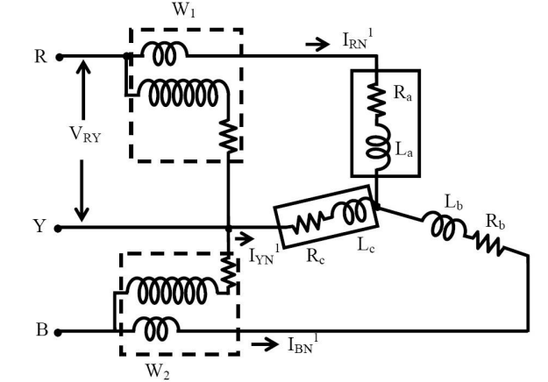
Fig 1: Connection diagram for three phase power measurement using two wattmeter method
The connection diagram for the measurement of power in three phase power measurement circuit using two wattmeter's method is shown in figure 1. This is irrespective of the circuit connection star or delta. The circuit may be taken as balanced or unbalanced one, balanced type being only a special case. Please note the connection of two wattmeter. The current coil of the wattmeter's 1 and 2 in series with R and B phase with the pressure voltage coils being connected across R-Y and-Y respectively. Y is the third phase in which no current coil is connected.
If star connected circuit is taken as an example the total instantaneous power consumed in the circuit is 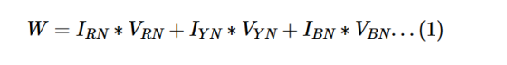
Each of the terms in the above expression equation (1) is the instantaneous power consumed by the phases. From the connection diagram, the circuit in and the voltages across the respective (current, pressure or voltage) coils in the wattmeter, W1 are IRN and
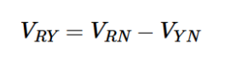
So, the instantaneous power measured by the wattmeter W1 is
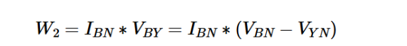
Some of the two readings as given above is,
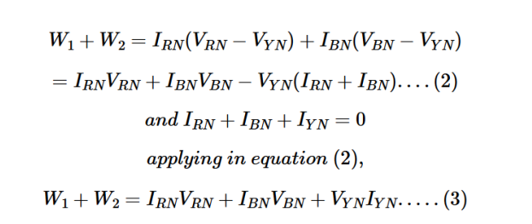
Equation (1) is compared with equation (3) to give the total instantaneous powerconsumed in the circuit . They are found to be same. The phasor diagram of threephase balanced star connected circuit is shown in figure 2.
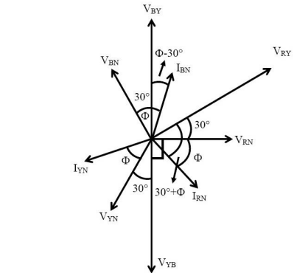
Fig 2: Phasor diagram of three phase balanced star connected circuit
Procedure
BALANCED LOAD :
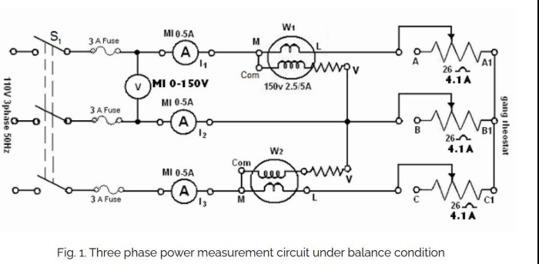
- Connect the circuit as shown in Fig. 1.
- Adjust the ganged rheostat for the maximum resistance.
- Switch on the supply.
- Close switch S1.
- 5. Read the meters to obtain VL, I1, I2 and I3. Note the wattmeter readingW1 and W2`(Note the multiplying factor on the wattmeter).
- Vary the load resistance and obtain at least five sets of observations, thecurrent should not exceed the limit (4.1 A).

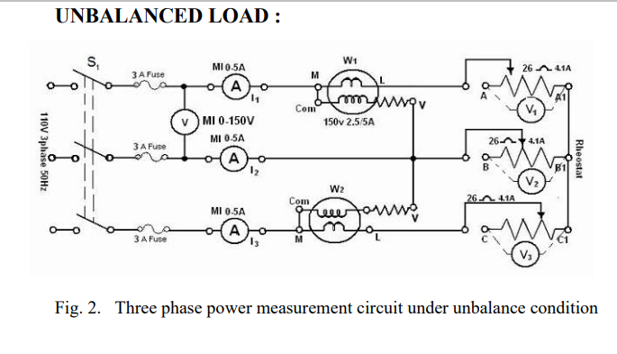
- Connect the circuit as shown in Fig. 2.
- Replace the ganged rheostat by three separate rheostats of 26 Ω, 4.1 Aand connect in a star.
- Adjust the three rheostats at the maximum values.
- Switch on the supply and set the autotransformer to 110 V.
- Close switch S1 and take five sets of observation for different rheostatsettings such that the reading of I1, I2 and I3 in each set is appreciablydifferent to create unbalanced loading condition. The current shouldnot exceed the limits in each arm.

SIMULATION BALANCED LOAD
CASE 1:
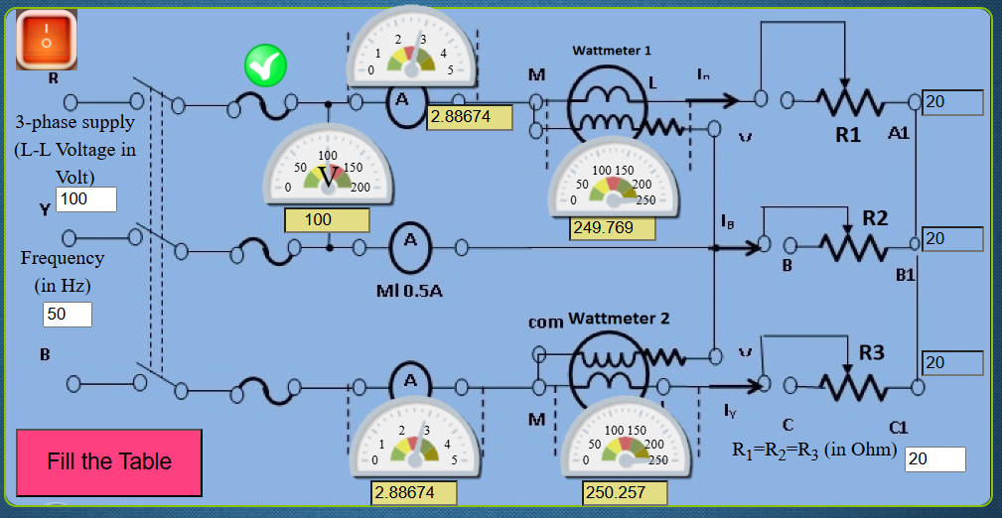
CASE 2:
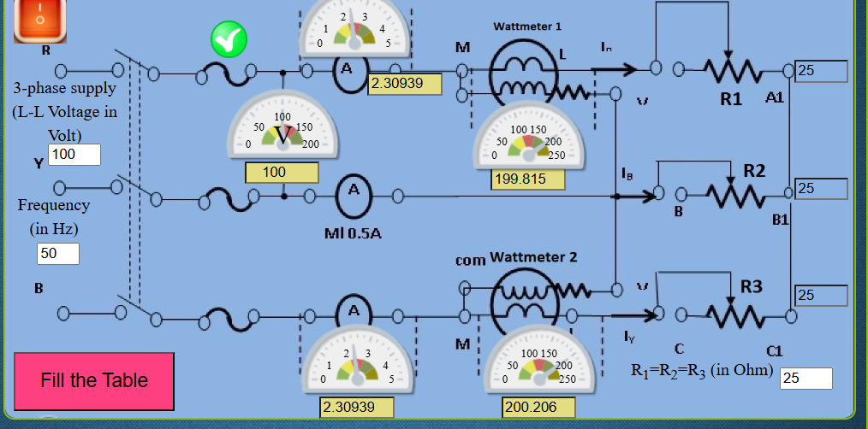

TABULATION
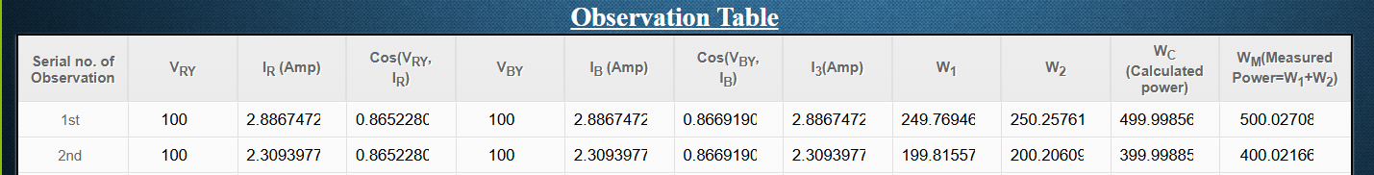

SIMULATION UNBALANCED LOAD
CASE1:
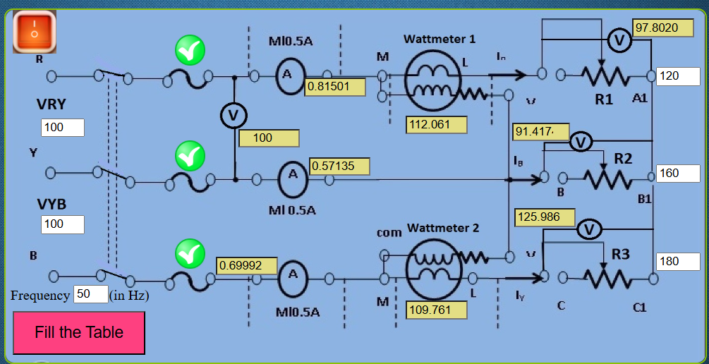

CASE 2:
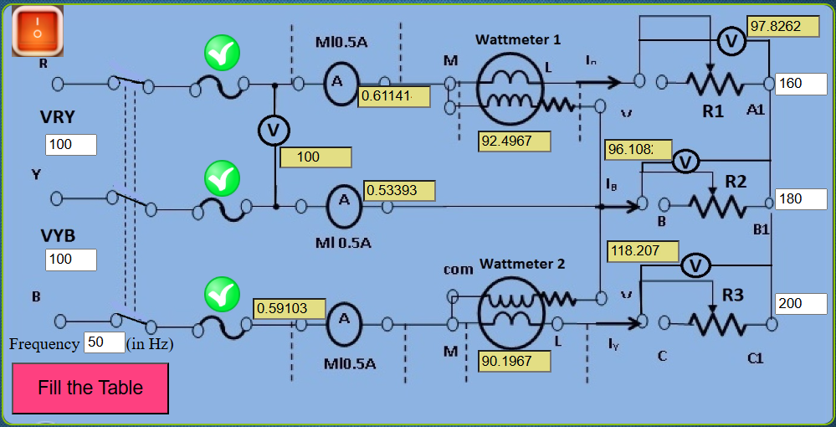

TABULATION
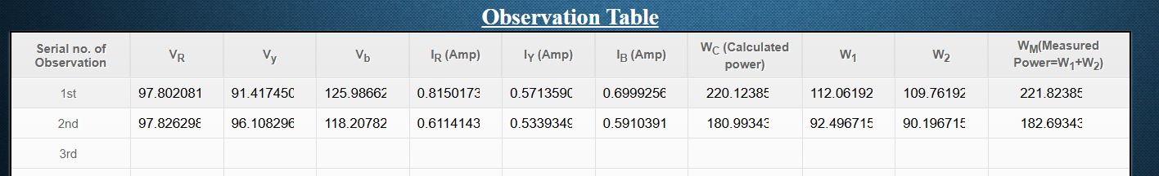

RESULT:
Thus ,the measurement of power is simulated and validated using virtual labs.

